Government of Tripura
Women’s College, Agartala
Dated Agartala, the 31st March, 2023
Department of Physics
Celebration of National Science Day 2023
Date: 28th February, 2023
Venue: Science-B
Time: 11.30 AM – 2 PM

Like previous years, department of physics and department of chemistry (02 beneficiary departments of DBT Star College Scheme) jointly organized the National Science Day (NSD-2023) on 28th February, 2023. This particular year, the National Science Day was celebrated throughout the nation with a slogan “Global Science for Global Wellbeing”. The programme started sharp at 11.30 AM with lighting the holy lamp and inaugural song by the students of both the departments’ viz., physics and chemistry. Professor Promod Ranjan Bhattacharjee, Retired Academician and pioneer researcher in the field of basic science has been invited as the chief guest cum inaugurator of the said programme. Immediately after the inaugural song, Dr. Samhita Bhaumik, Head, department of chemistry delivered a short welcome address highlighting the importance of continuing education in any field especially in the field of science. After the welcome address, the Sr. most faculty of the physical science division of this college, Dr. Gautam Chel delivered a short power point presentation on the importance of National Science Day. Thereafter, 03 (three) students viz. Aakangsha Paul, 5th Semester, CEMH, Barnita Saha, 3rd Semester, PHSH and Sanghita Das, 3rd Semester, PHSH delivered short speech highlighting the works and research arena of Sir C. V. Raman. After these short speeches, the Chief Guest Dr. Promod Ranjan Bhattacharjee delivered the Special lecture in a very popular manner on the topic “Research in Basic Science”. All the student-participants were really benefitted with his valuable lectures and many of them actively participated in the interaction session. After his valuable lecture, Dr. Manidipa Debbarma, Principal of this college delivered the presidential address emphasizing the importance of science in daily life. Finally, the programme ended with the vote of thanks to various dignitaries on/off the dais by Dr. Subrata Deb, Head, department of Physics. Nearly 70-75 students of different semesters (from both Honours and General) have participated in the said programme.

SOME GLIMPSES OF NATIONAL SCIENCE DAY-2023
Focal Theme: Global Science for Global Wellbeing
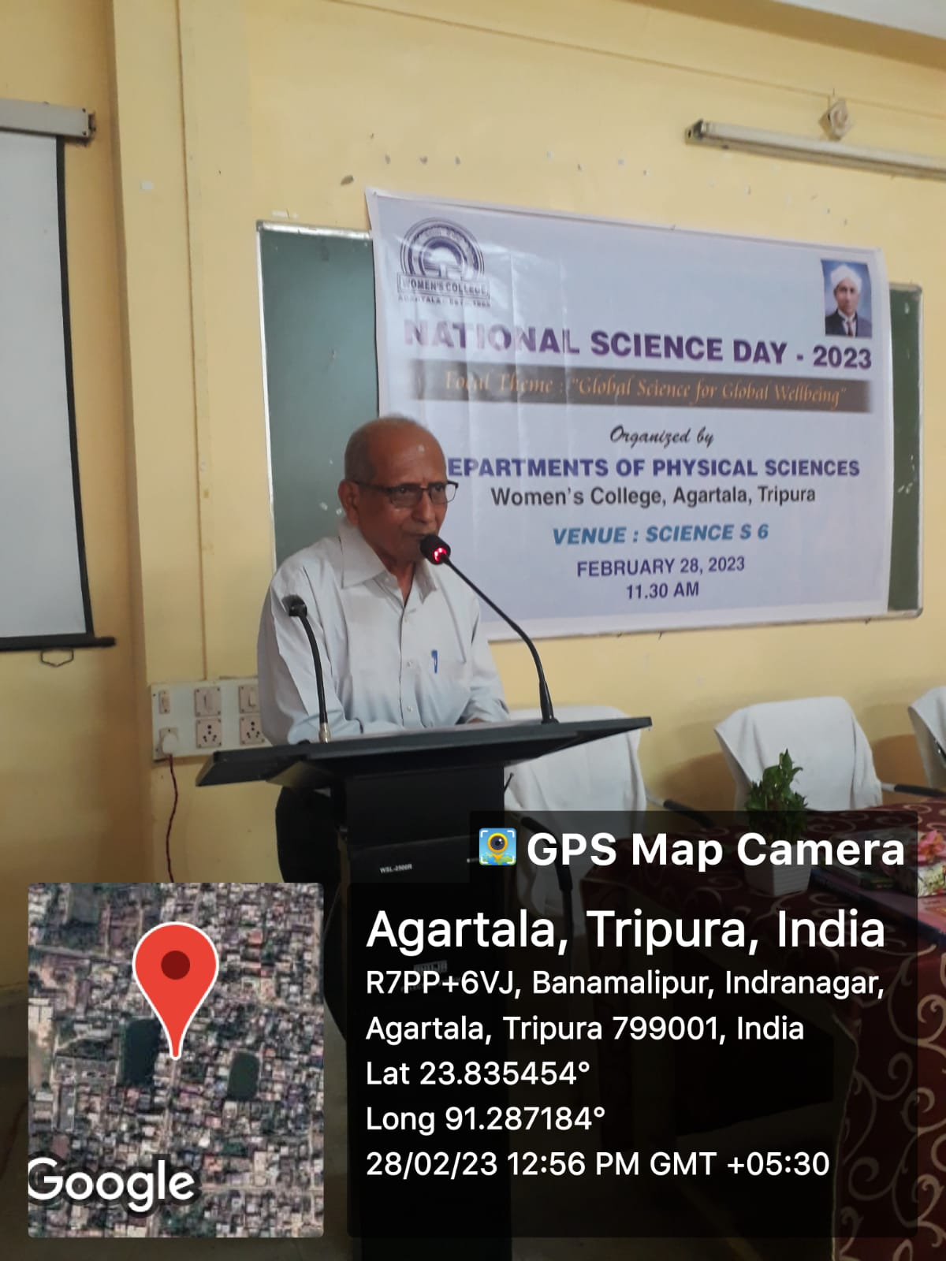
Eminent Academician cum researcher Dr. Promod Ranjan Bhattacharjee delivering his lecture during National Science Day (28th February, 2023)
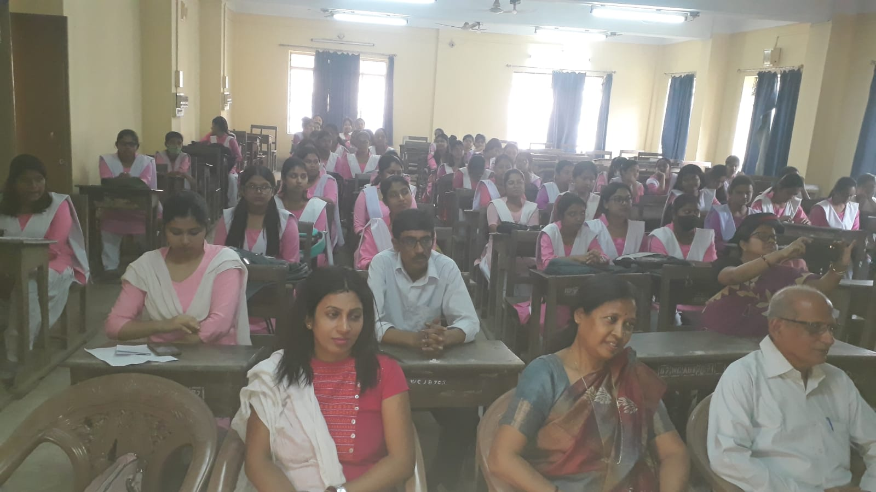
Students’ participants during the National Science Day-2023 (28th February, 2023)
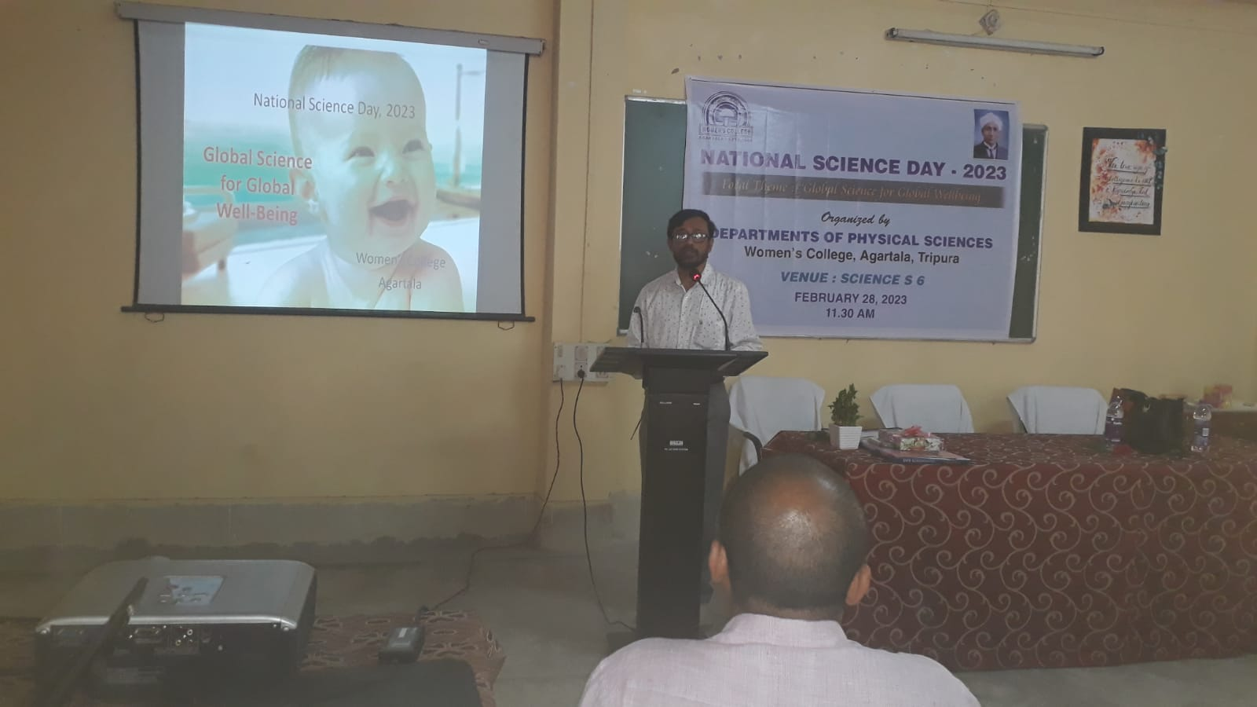
Dr. Gautam Chel, Associate Professor, Dept. of Chemistry delivering his presentation during the National Science Day-2023 (28th February, 2023)

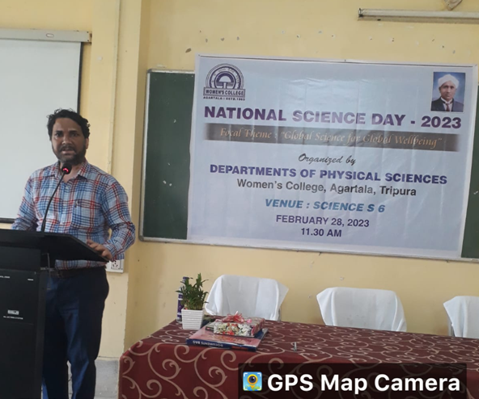
Dr. Subrata Deb, Head, Dept. of Physics delivering Vote of thanks during the National Science Day-2023 (28th February, 2023)

